Table of Contents

1.0 Introduction 3

1.1 Project Background 3

1.2 Project Objective 4

1.3 Project Scope 4

1.4 Project Specification 5

1.5 Project Deliverables 5

2.0 Project Plan 6

2.1 Gantt Chart 6

3.0 Design 7

3.1 Architectural Design 7

3.2 Use Case Diagram 8

4.0 Implementation 9

4.1 Microsoft Azure 9

4.1.1 Resource group 9

4.1.2 Database 10

4.1.3 Service Plan 11

4.1.4 Traffic Manager 13

4.2 Web Application Screenshot 16

4.2.1 Home Page 16

4.2.2 Register 17

4.2.3 Login 18

4.2.4 FAQ 19

4.2.5 Booking 20

5.0 Test Plan 21

5.1 Performance Test 21

5.2 Unit Testing 23

5.2.1 Register 23

5.2.2 Login 23

5.2.3 Search Flight 23

6.0 Conclusion 24

7.0 References 25

# 1.0 Introduction

## 1.1 Project Background

Ukraine International Airlines (UIA) is the flagship carrier and largest airline in Ukraine. It operates domestic and international passenger flights and cargo services to Europe, the Middle East, the United States, and Asia. The airline is eager to expand into new markets, but problems with its website prevented it from adequately serving customers beyond Ukraine. The site experienced severe denial-of-service (DOS) attacks, which hurt site performance and reliability, and it did not have the performance needed to host visitors from many parts of the world.

UIA has long used technology to reduce costs, innovate, and improve customer service. It has gone to a paperless cockpit and uses sophisticated software for analysing fuel economy. The airline decided that it once again needed to innovate its way out of its web challenges. Dmitriy Prudnikov, Chief Information Officer at Ukraine International Airlines, realized that migrating the website out of UIA datacentres into a public cloud could solve all these problems.

## 1.2 Project Objective

Ukraine International Airlines (UIA), is looking at designing and developing an Online Flight Booking System. UIA looked at both Microsoft Azure and Amazon Web Services and chose Azure. Azure was also very compatible with open source software.

## 1.3 Project Scope

Ukraine International Airlines (UIA) will be planning, designing, developing and testing the online flight booking system based on the requirements defined. The project is broken down into several sections and the completion date for each section is recorded by building a Gantt chart. The project will be completed when the web application is tested to be fully functional and deployed to Microsoft Azure. By the end of this project, a documentation that include project plan, web application design, implementation and test plan will be created.

## 1.4 Project Specification

1. Maintainability – To ensure that the status of online flight booking system is easily retained so that any maintenance process can be performed. Also allow the web application to be upgradable at any moment.
2. Availability – To ensure the web application is always available to the users no matter how many users are operating its functions.
3. Monitoring – To ensure the web application is easily monitored at every moment including each user’s activities so that any error or problem can be identified easily.
4. Provisioning – To ensure that the online flight booking system equally aligns with the SQL server database of the Microsoft Azure platform.
5. Scalability – To ensure that the web application is able to scale flexibly to meet with any modified requirements.

## 1.5 Project Deliverables

The online flight booking system will be able to be accessed by many browsers including Mozilla Firefox, Microsoft Edge, Google Chrome, and Safari. It allows the users to perform the following actions:

* Manage your entire booking process
* Creation of customer profile
* Configure the online booking engine so that it returns customized information, based on where your customers are located and the type of trip they are booking

# 2.0 Project Plan

## 2.1 Gantt Chart

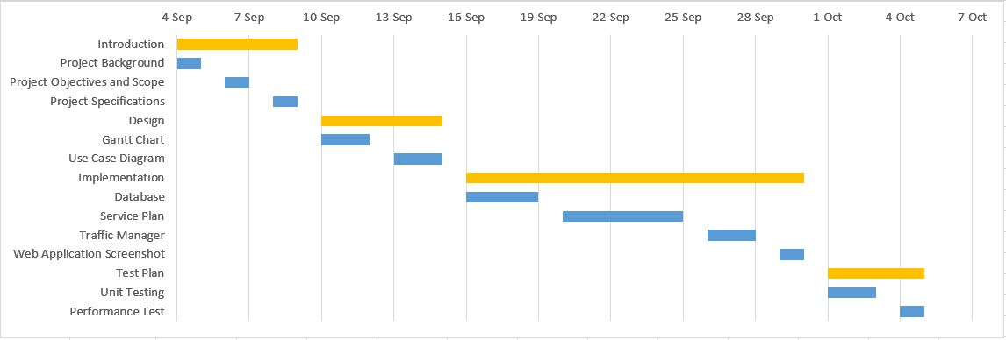

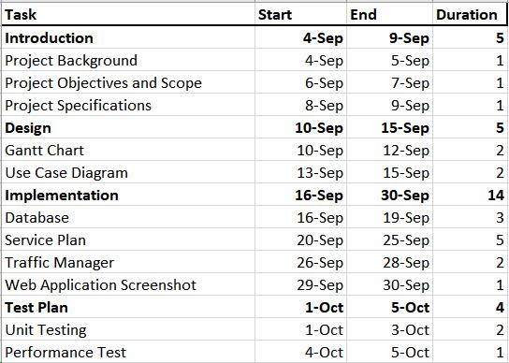

# 3.0 Design

## 3.1 Architectural Design

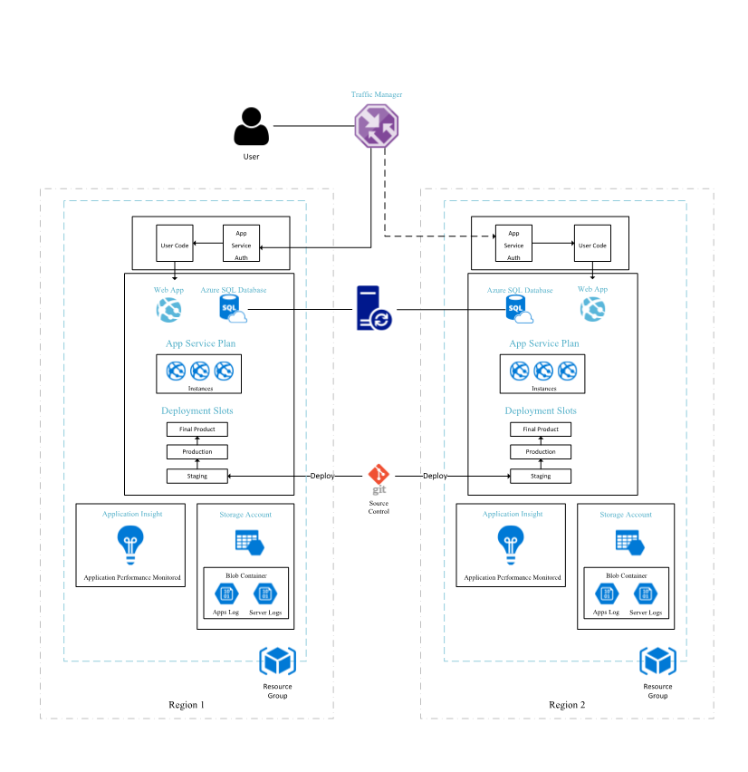

The figure above shows the architectural design of this project. As seen in the figure, when a user begins to gain access to the web application, the traffic manager will obtain the user’s location and based on its judgement to speed and performance. This will notify the region that the user is trying to access from and redirect to the nearest web application server.

## 3.2 Use Case Diagram

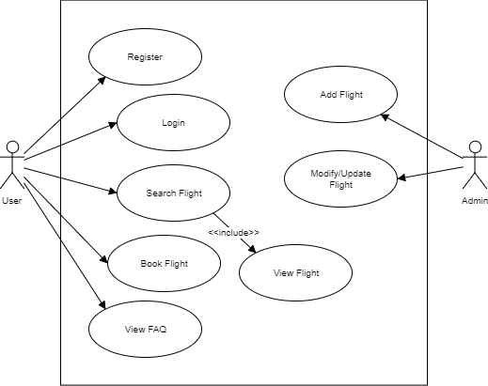

# 4.0 Implementation

## 4.1 Microsoft Azure

### 4.1.1 Resource group

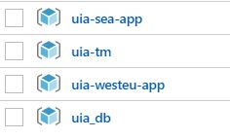

Figure 4.1.1 Resource Groups

The figure shown above shows the resource groups that are present in this project. As seen in the figure, there is the database, traffic manager, 2 of the region that is South East Asia and west Europe.

### 4.1.2 Database

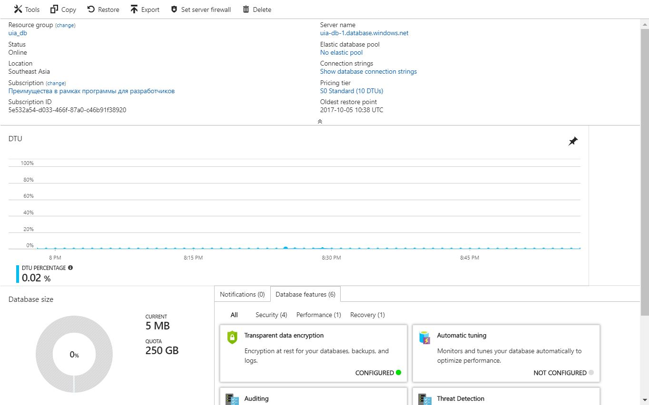

Figure 4.1.2 Database

The figure above shows the database that is used in this project. It will display the pricing tier that the database is running on and the bottom left shows how much space is used or left.

### 4.1.3 Service Plan

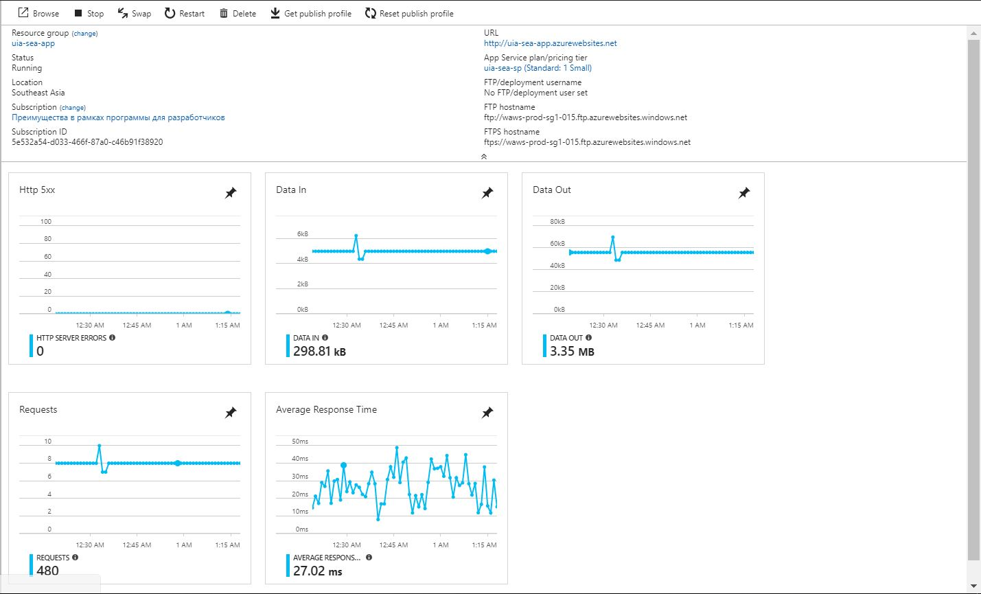

Figure 4.1.3(a) SEA service

The figure above shows the service plan for the web application deployed at south east asia. It shows the URL of the web application and the stats including the data in, data out, requests, and average response time.

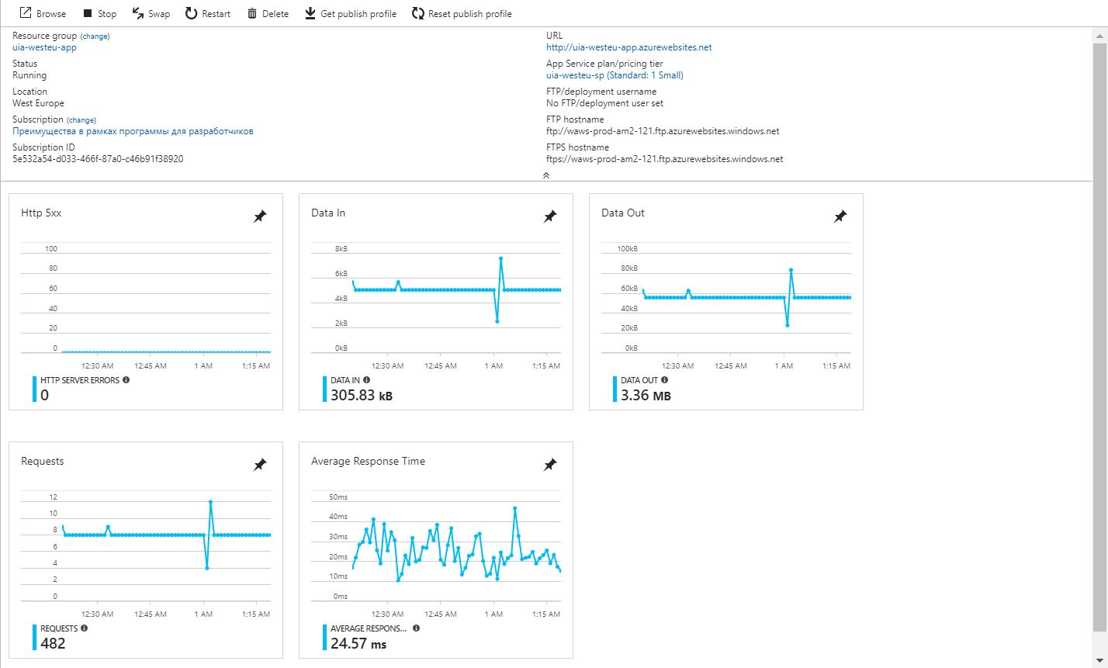

Figure 4.1.3(b) West EU service

The figure above shows the service plan for the web application deployed at west europe. It is similar to the south east asia service plan but is deployed in west europe instead. It displays the url for the west europe region and the stats including the data in, data out, requests, and average response time.

### 4.1.4 Traffic Manager

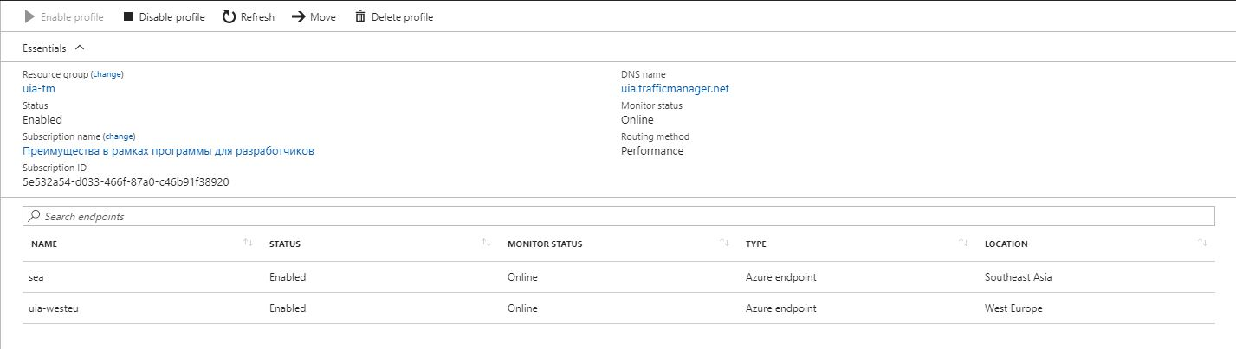

Figure 4.1.4(a) Traffic Manager

The figure above shows the traffic manager of the online flight booking system. The main purpose of this is to redirect the user to the nearest endpoint for the best performance while utilizing the web application. It shows both the endpoints that is deployed on azure being sea and uia-westeu.

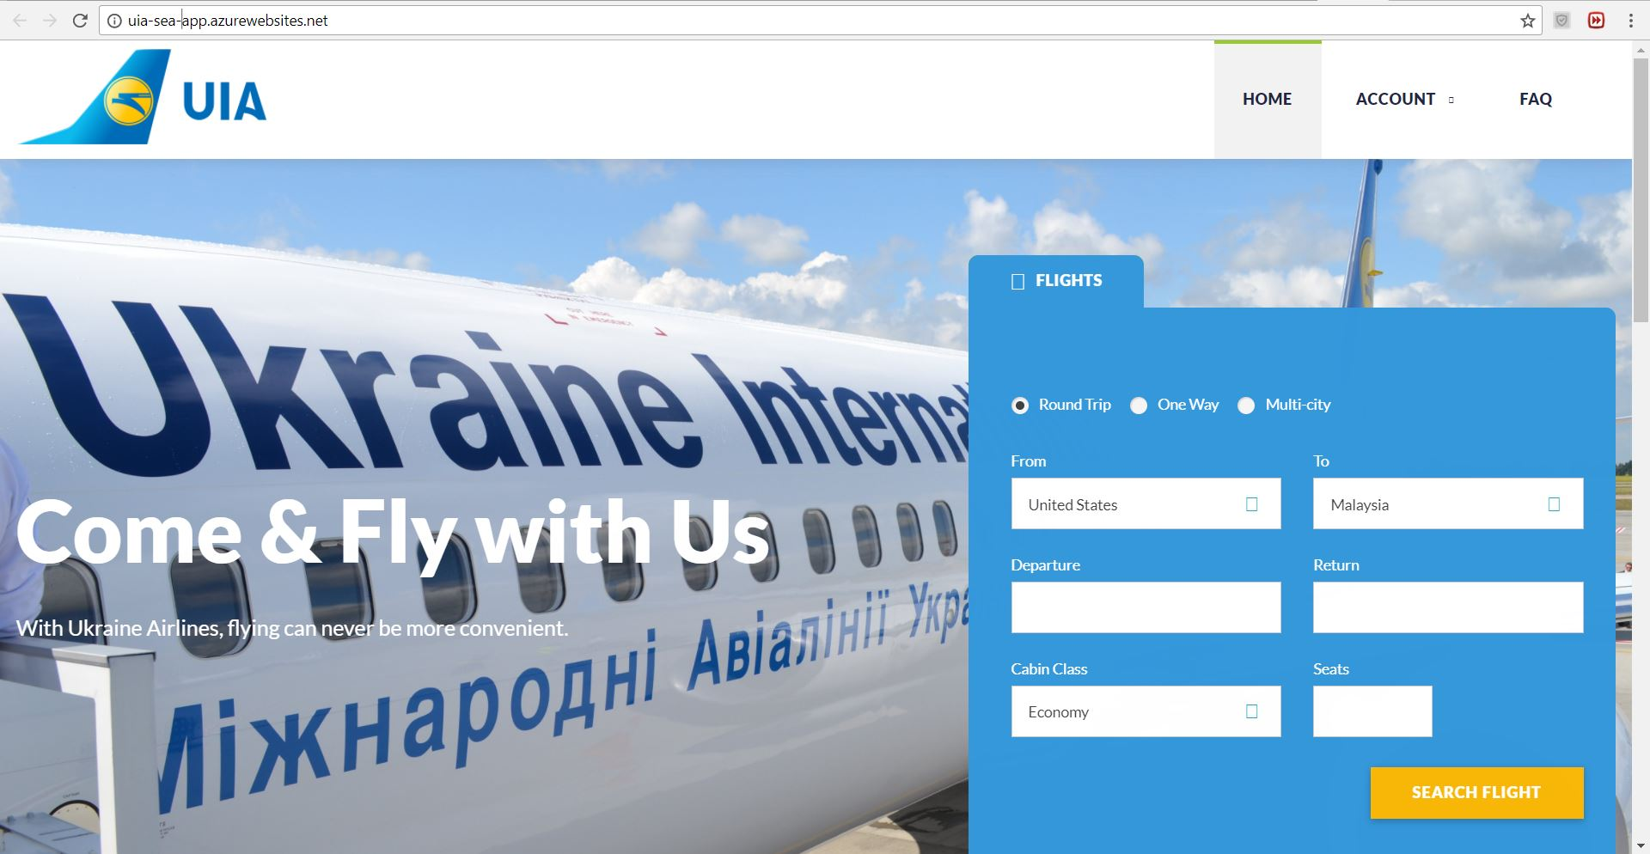

Figure 4.1.4(b) SEA endpoint

The figure above shows the web application that user will be redirected to south east asia endpoint. The url shows http://uia-sea-app.azurewebsites.net/ which is the web application of the south east Asian region.

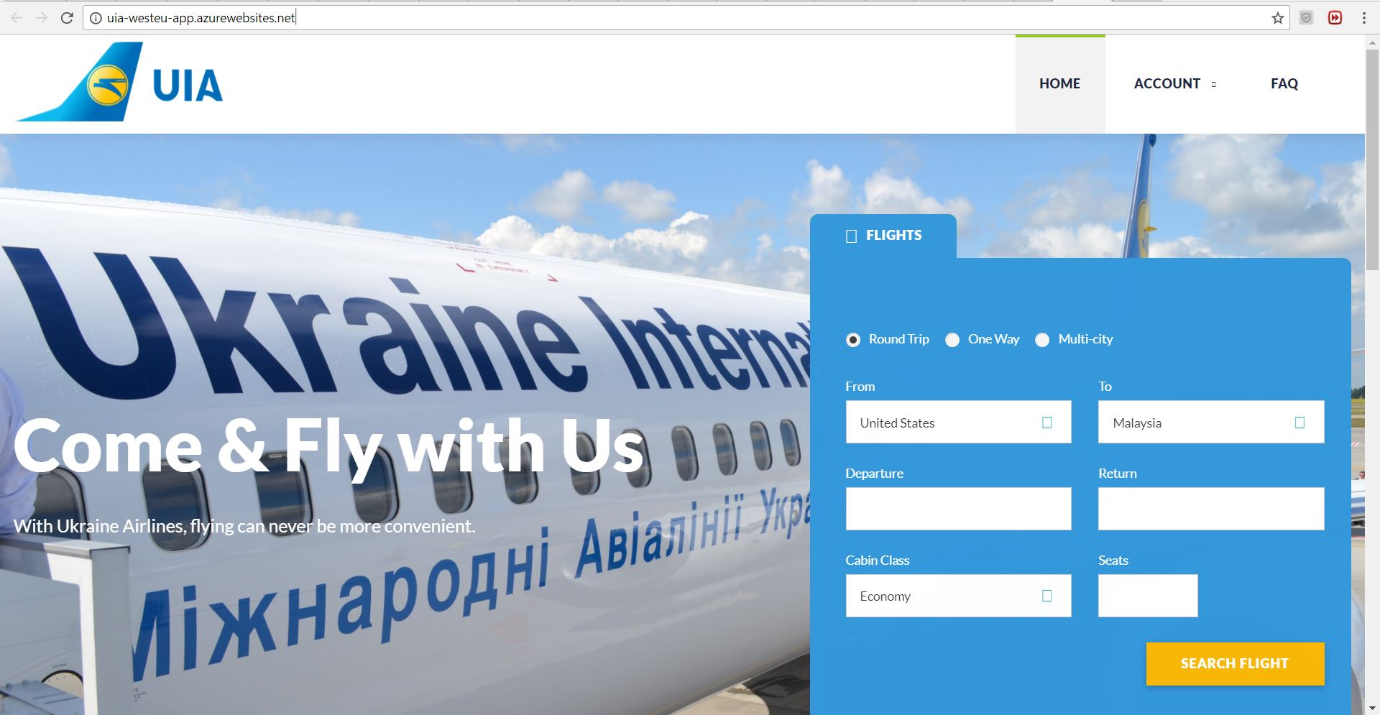

Figure 4.1.4(c) West EU endpoint

The figure above shows the web application that user will be redirected to west europe endpoint. The url shows http://uia-westeu-app.azurewebsites.net/ which is the web application of the west europe region.

## 4.2 Web Application Screenshot

### 4.2.1 Home Page

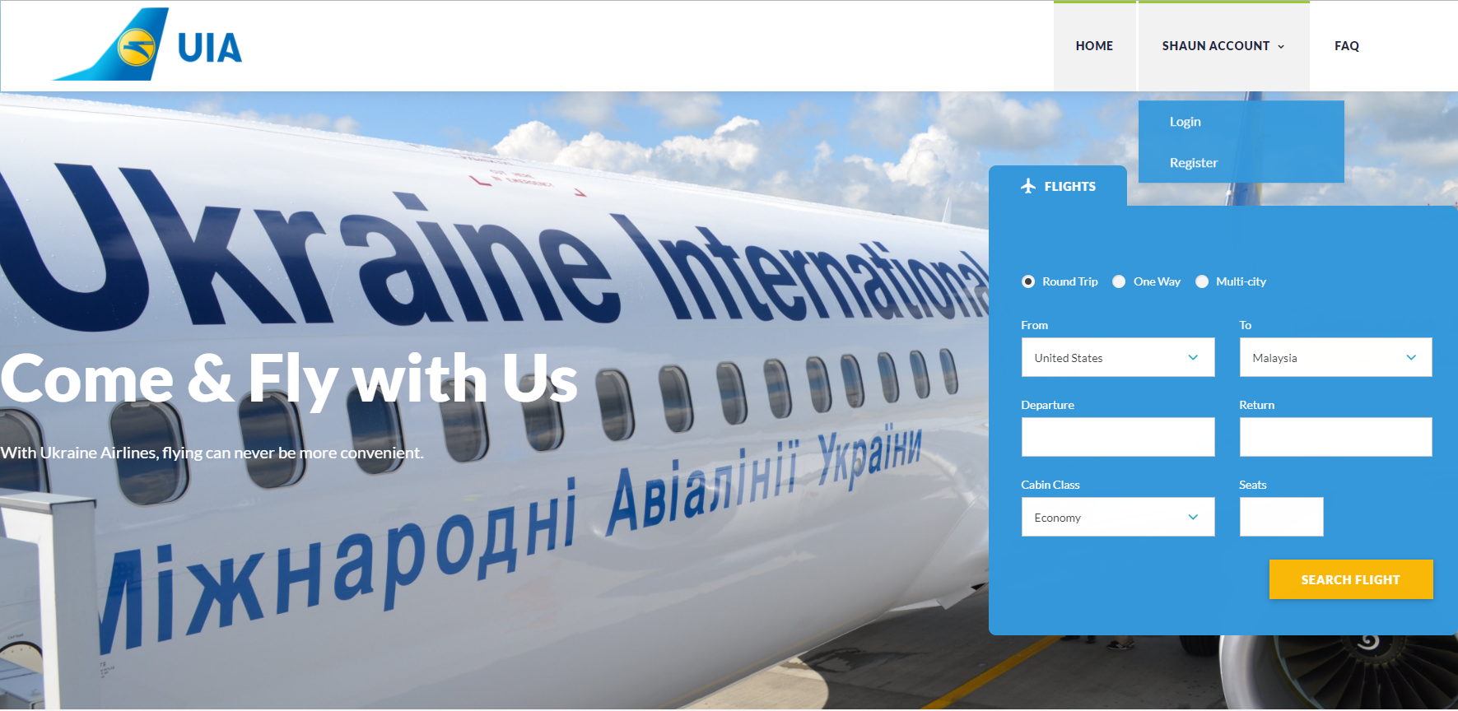

Figure 4.4.1 Home Page

The figure above shows the Home Page of the web application that allows the users to book a flight online. The user can access the navigation bar on top to register and login page under account, while access the FAQ page if there are any questions or uncertainties. The design of this web application follows a template that can be obtained online.

### 4.2.2 Register

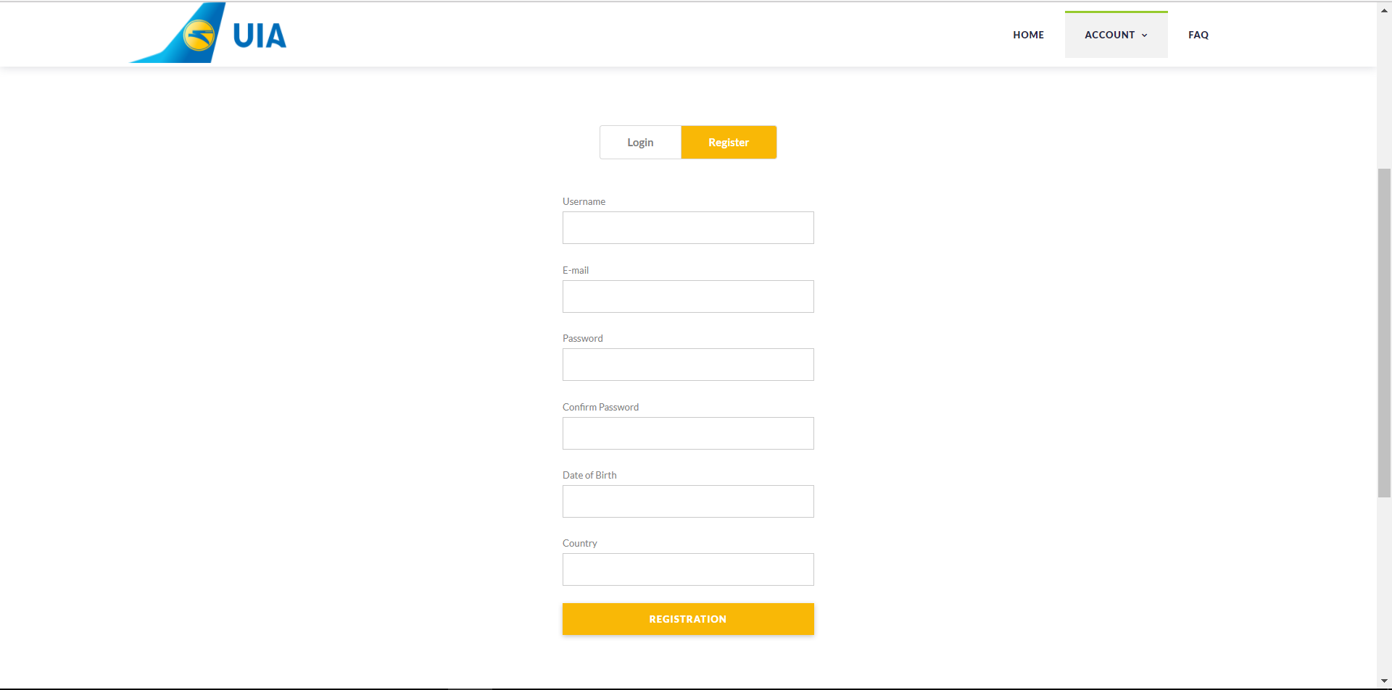

Figure 4.4.2 Register Page

The figure above shows the register page of the web application. This page allows any new user to register by entering their username, e-mail, password, date of birth, and country. After filling the text fields and click the register button, the data will be recorded as the users account so that the credentials may be used for login.

### 4.2.3 Login

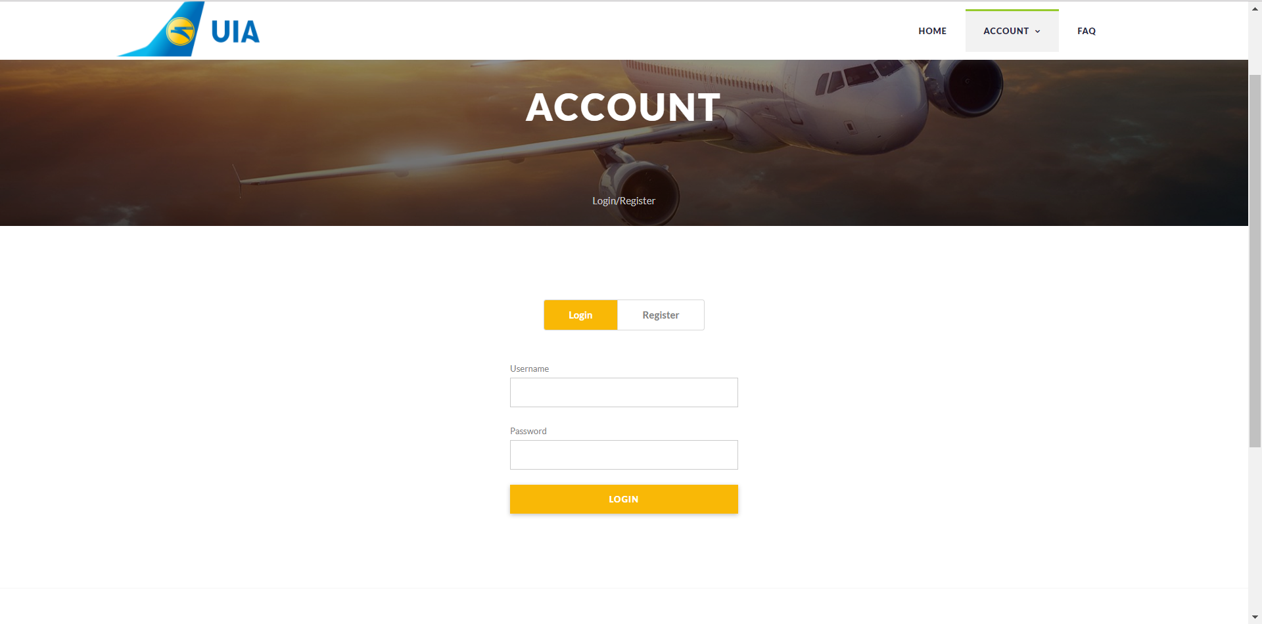

Figure 4.4.3 Login Page

The figure above shows the login page of the web application. The user will enter their username and password in the text fields provided and click on the login button, then the system will verify the credentials entered, which will allow or deny access to the functions of the flight booking system depending on the eligibility of the username and password.

### 4.2.4 FAQ

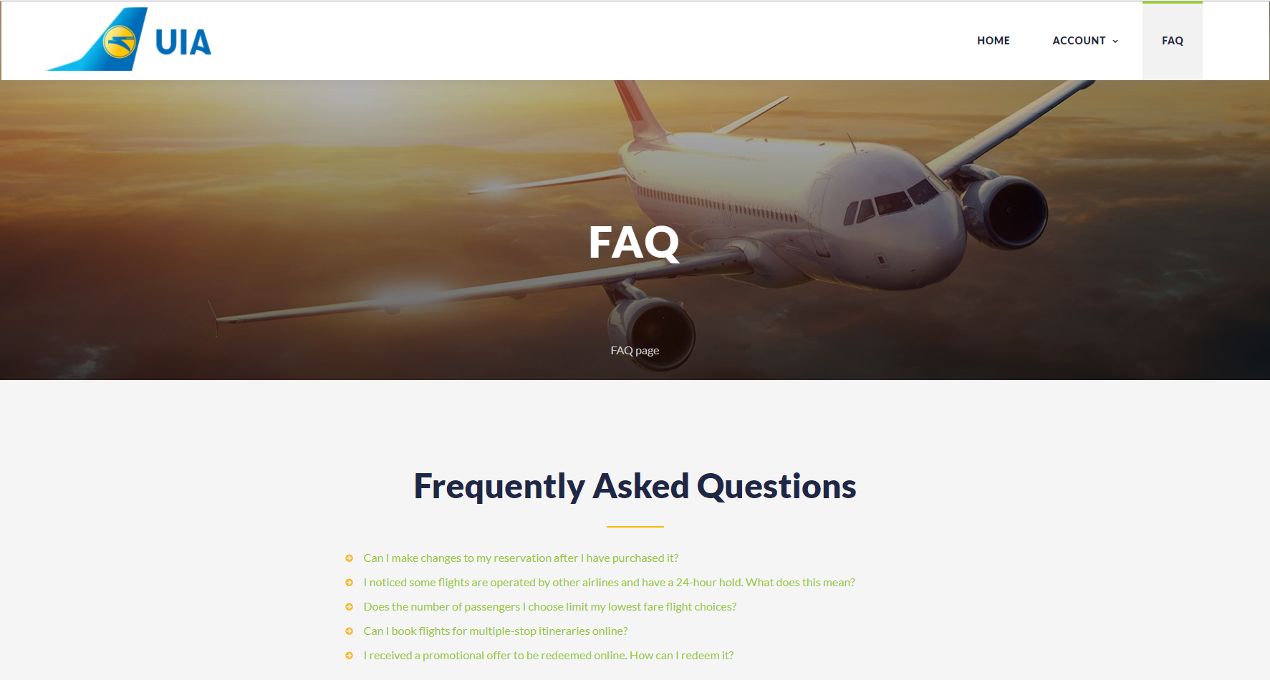

Figure 4.2.4 FAQ Page

The figure above shows the frequently asked questions page of the web application. It shows all the questions that the user may ask and provide answers and solutions. This will help users who are uncertain of the functions in the online flight booking system.

### 4.2.5 Booking

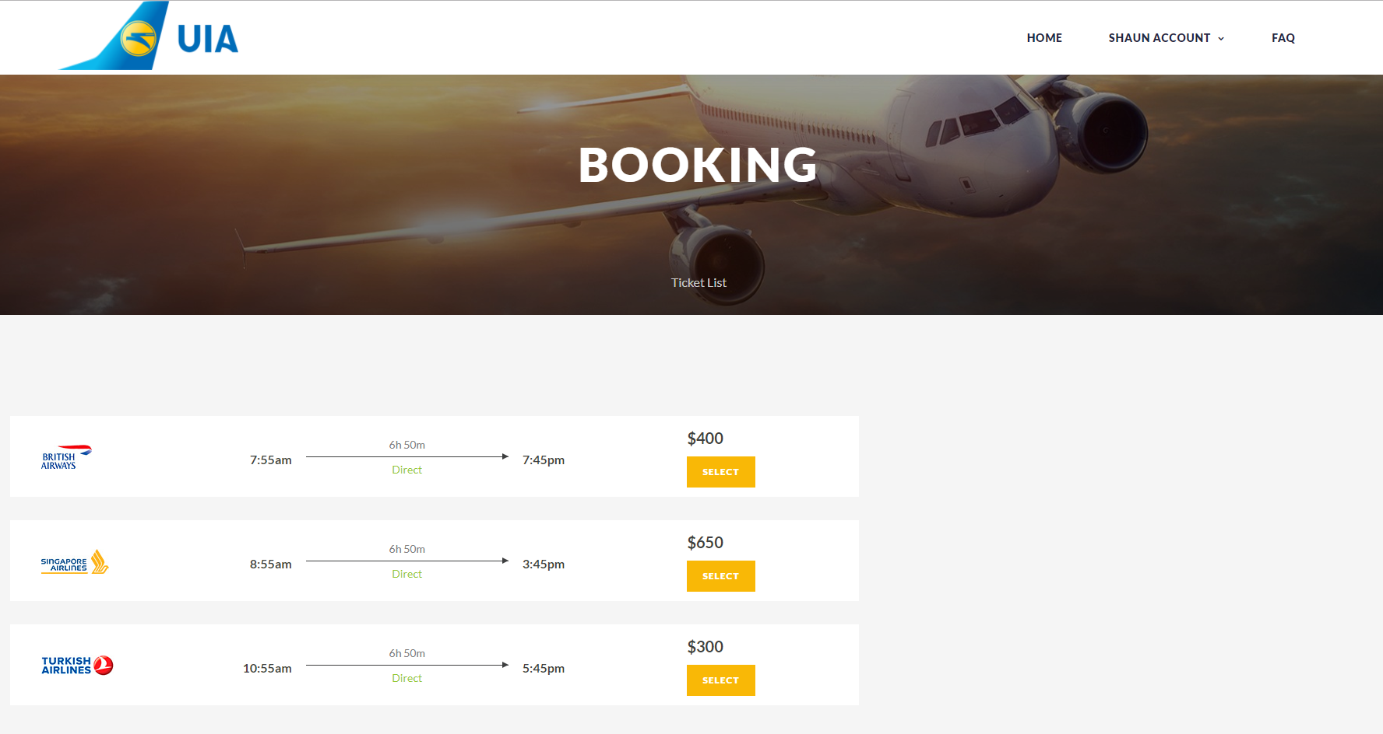

Figure 4.2.5 Booking Page

The figure above shows the booking page of the web application. After the user has filled in the search and click search flight button, the user will be brought to the booking page and display all the flights that meet the search requirements. Each flight will show the partner of the related flight, departure time, arrival time, flight duration, and price. The user will then have to slick on the select button to proceed with the purchase flight ticket.

# 5.0 Test Plan

## 5.1 Performance Test

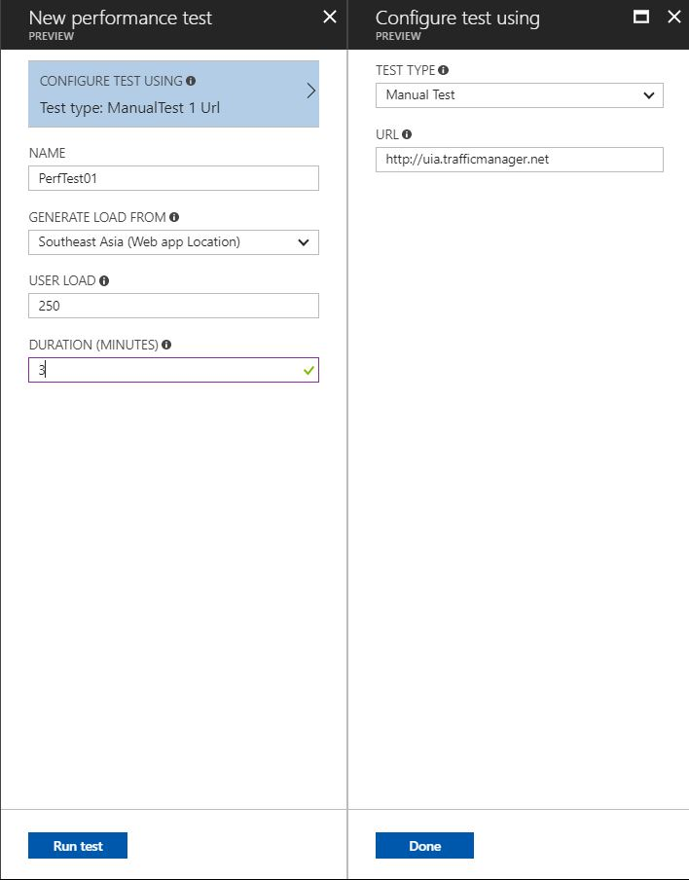

Figure 5.1(a) Performance test setting

The figure above shows the settings that are selected for the performance test of the web application that was deployed. In this test, a total of 250 users will be loaded for a duration of 3 minutes will be handled.

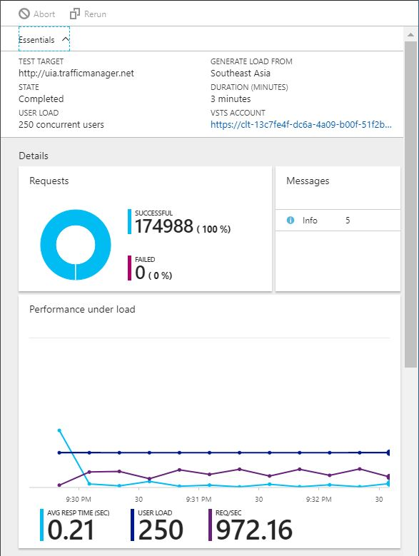

Figure 5.1(b) Performance test result

The figure above shows the result of the performance test with the setting of Figure 5.1(a). As the performance test is completed with the user load of 250 and duration of 3 minutes, it shows that the average response time was 0.21 seconds. The result is sufficient, therefore the test was successful.

## 5.2 Unit Testing

### 5.2.1 Register

|  |  |  |
| --- | --- | --- |
| Test Case | Expected Output | Actual Output |
| Enter all fields accordingly and click register button | Registers user data successfully | As expected |
| Enter fields except username and click register button | User will be notified and prompted to enter username | As expected |
| Enter fields except password and click register button | User will be notified and prompted to enter password and confirm password | As expected |
| Leave all fields empty and click register button | Does not register user and notify to enter all fields | As expected |

### 5.2.2 Login

|  |  |  |
| --- | --- | --- |
| Test Case | Expected Output | Actual Output |
| Enter registered username and password then click login button | User will login successfully | As expected |
| Enter username with no password and click login button | User will be notified to fill all fields to login | As expected |
| Enter password with no username and click login button | User will be notified to fill all fields to login | As expected |
| Leave all fields empty and click login button | User will be notified to fill all fields to login | As expected |

### 5.2.3 Search Flight

|  |  |  |
| --- | --- | --- |
| Test Case | Expected Output | Actual Output |
| Enter flight locations, dates, and seats then click search flight | Display all available flights that meet requirements | As expected |
| Enter all fields except departure | User will be notified and prompted to fill departure | As expected |
| Enter all fields except arrival | User will be notified and prompted to fill arrival | As expected |

# 6.0 Conclusion

To conclude, the web application that was developed for Ukraine International Airlines (UIA) has allows the users to book their flights online with efficiency. The online flight booking system that was developed will satisfy the requirements defined by UIA to reduce costs, innovate, and improve customer service. Besides, the decision to host the developed web application on Microsoft Azure has met the needs of UIA. Besides that, by utilizing the cloud services provided by Microsoft Azure, has enable this project to accelerate the setup and deployment of the solution. For example, new servers will take nearly 7 weeks to deploy in an on-premise environment. However, it will only take a few minutes to deploy in the cloud computing environment.

Additionally, the Traffic Manager of Microsoft Azure is implemented in order to control requests from web clients. Performance traffic routing is also done by deploying endpoints in multiple different regions across the world. It will take part in improving the average response time of the web application by routing traffic to the region that is closest to the client. Last of all, the web application has undergone performance test to ensure it is able to handle a certain user load without heavily influencing the performance and unit testing to ensure the functions are fully working.

# 7.0 References

Github URL: <https://github.com/shaunng95/DDAC_TP036638>

Azure URL: <http://uia-sea-app.azurewebsites.net>